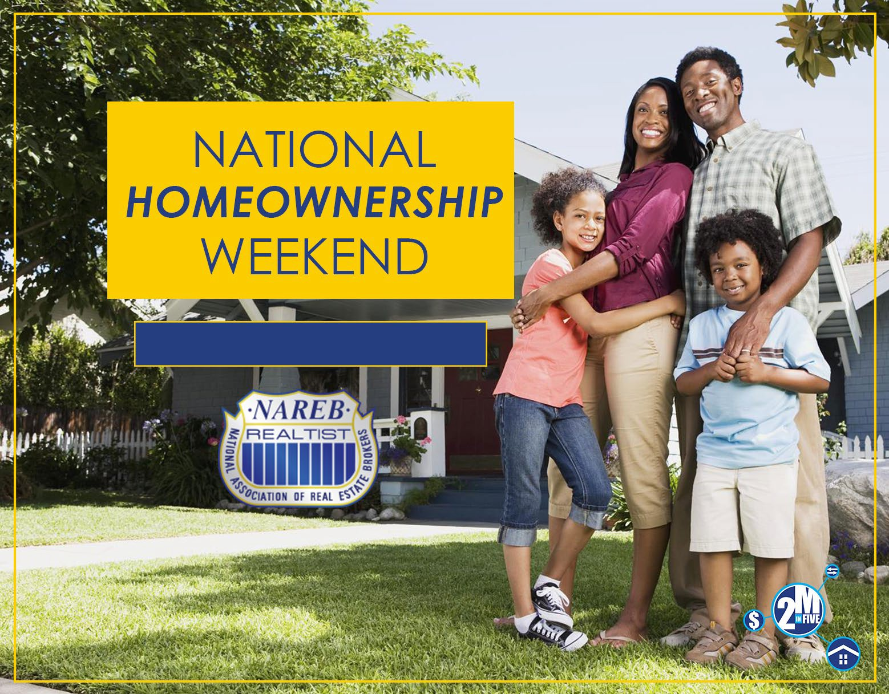

NEW ORLEANS REAL ESTATE BROKERS ASSO., INC.
JUNE 22, 2019 / 10AM TO 2:00PM

Homebuyer Workshops Locations

ORLEANS PARISH
Gentilly : Beacon Light FGBC –
1937 Mirabeau Ave., N.O., LA 70122
Mid-City/Carrollton: Xavier Community Outreach Center
7934 Edinburgh St., N.O., LA 70125
Algiers: 3001 General DeGaulle Dr. N.O., LA 70114
N.O. East: Southern University - SUNO
6801 Press Drive, N.O., LA 7012

JEFFERSON PARISH
Metairie: East Jefferson Regional Library
4747 West Napoleon Ave., Metairie, LA 70001
Harvey: West Jefferson Regional Library
2751 Manhattan Blvd., Harvey, LA 70058

Please register online at www.neworleansrealtists.com
For more information, please contact (504) 909-3255 or (504 ) 382-0909

