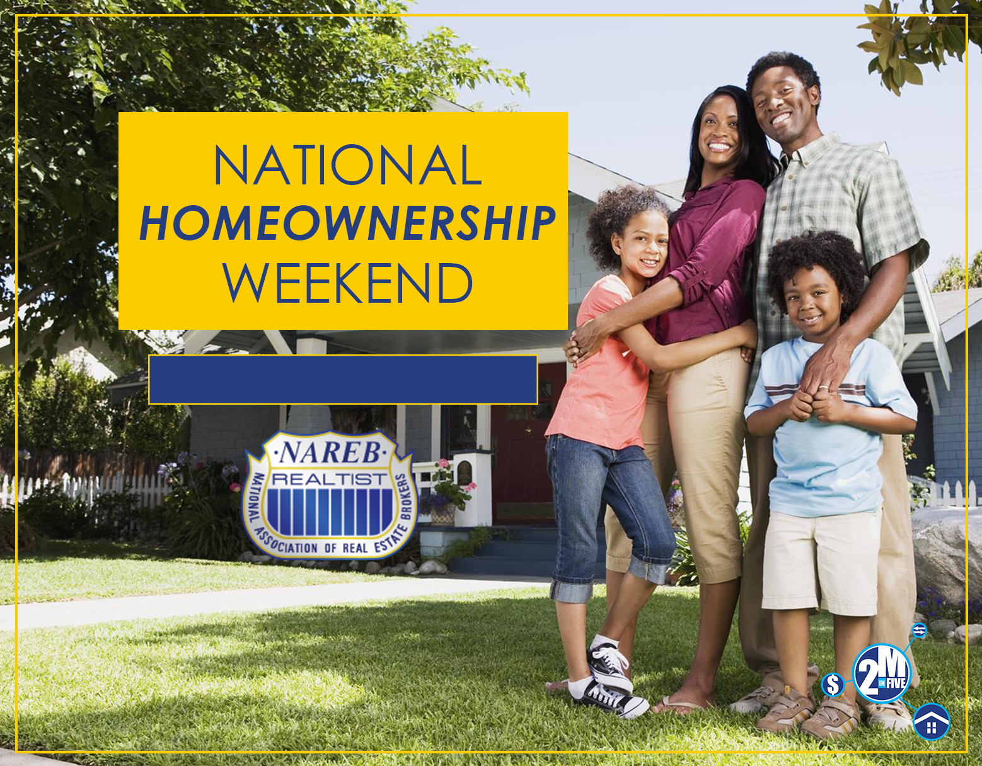
--
NAREB NATIONAL OFFICE
9831 Greenbelt Road, Lanham, MD 20706
Call: 301-552-9340 / Fax: 301-552-9216
www.nareb.com
June 24, 2017 | 10 AM to 2 PM

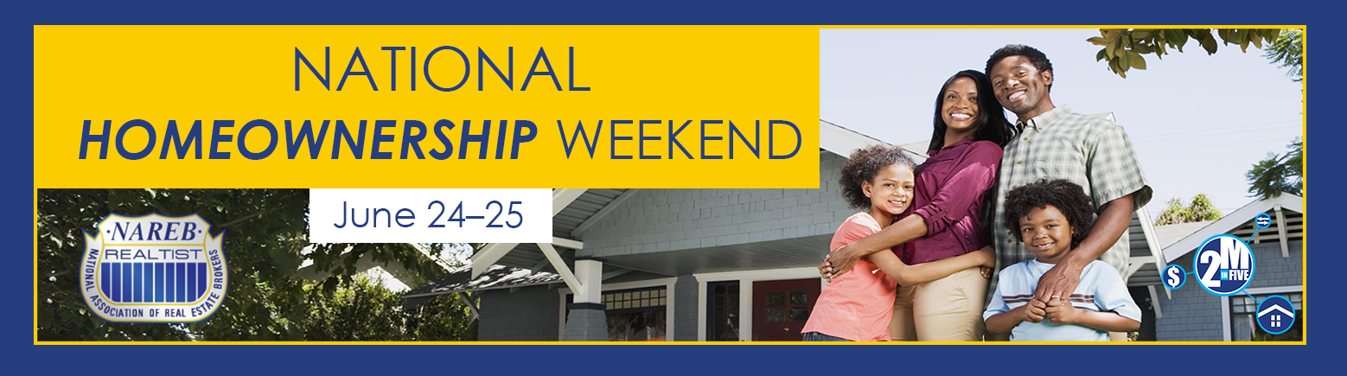

JUNE 24, 2017 10AM-2PM
SIGN-IN SHEET

Date | First Name | Last Name | Address | City | State | Zip Code | Phone | Email | Pre- Approved (Y/N) | Under Contract with an agent (Y/N)

